DSA06 DATA HANDLING AND VISUALIZATION
ACTIVITY: MAP STORYTELLING CHALLENGE — MS-D24
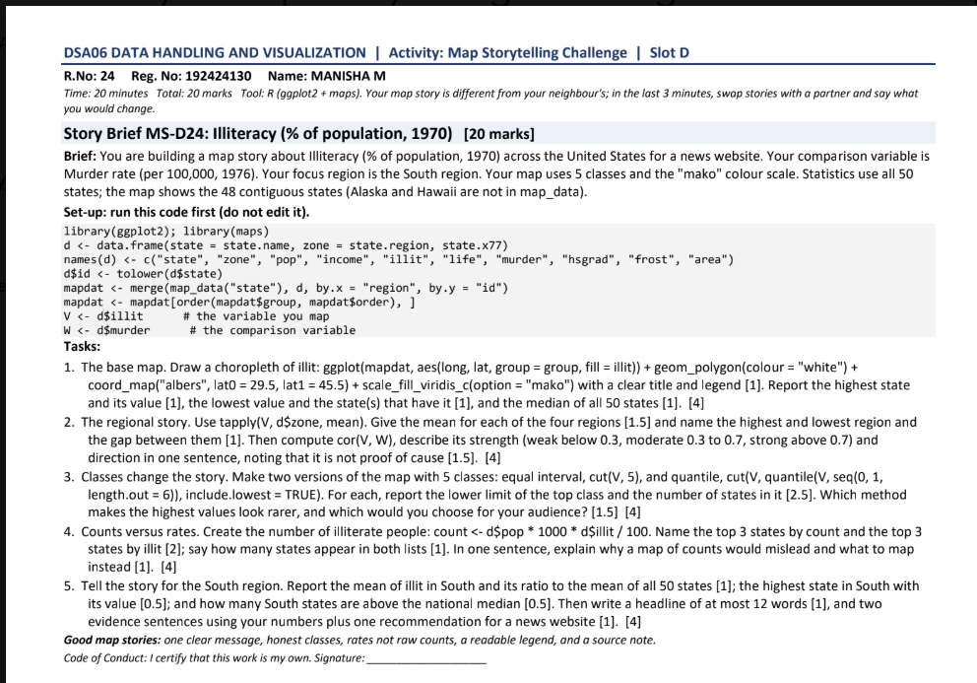

Set-up code from the question
library(ggplot2); library(maps)
d <- data.frame(state = state.name, zone = state.region, state.x77)
names(d) <- c("state", "zone", "pop", "income", "illit", "life",
"murder", "hsgrad", "frost", "area")
d$state <- tolower(d$state)
mapdat <- merge(map_data("state"), d, by.x="region", by.y="state")
V <- d$illit
W <- d$murder
The question's set-up uses state.x77, which contains 50 states. The map polygon data has the 48 contiguous states only, so Alaska and Hawaii are absent from the map but remain in national statistics.

Question 1 — Base choropleth map
Use a continuous fill scale because illiteracy is a numeric rate. Keep the title explicit, use a readable legend, draw thin white borders, and use the Albers projection requested in the task.
ggplot(mapdat, aes(long, lat, group=group, fill=illit)) +
geom_polygon(colour="white", linewidth=0.25) +
coord_map("albers", lat0=29.5, lat1=45.5) +
scale_fill_viridis_c(option="mako", name="Illiteracy (%)") +
labs(title="Illiteracy across the United States, 1970",
subtitle="48 contiguous states; Alaska and Hawaii excluded") +
theme_void()
# Highest, lowest and median across all 50 states:
d[which.max(d$illit), c("state","illit")]
d[which.min(d$illit), c("state","illit")]
median(d$illit)
The highest state, lowest state, and median are reported by the three commands above. This avoids confusing the 48-state map with the 50-state statistical summaries.
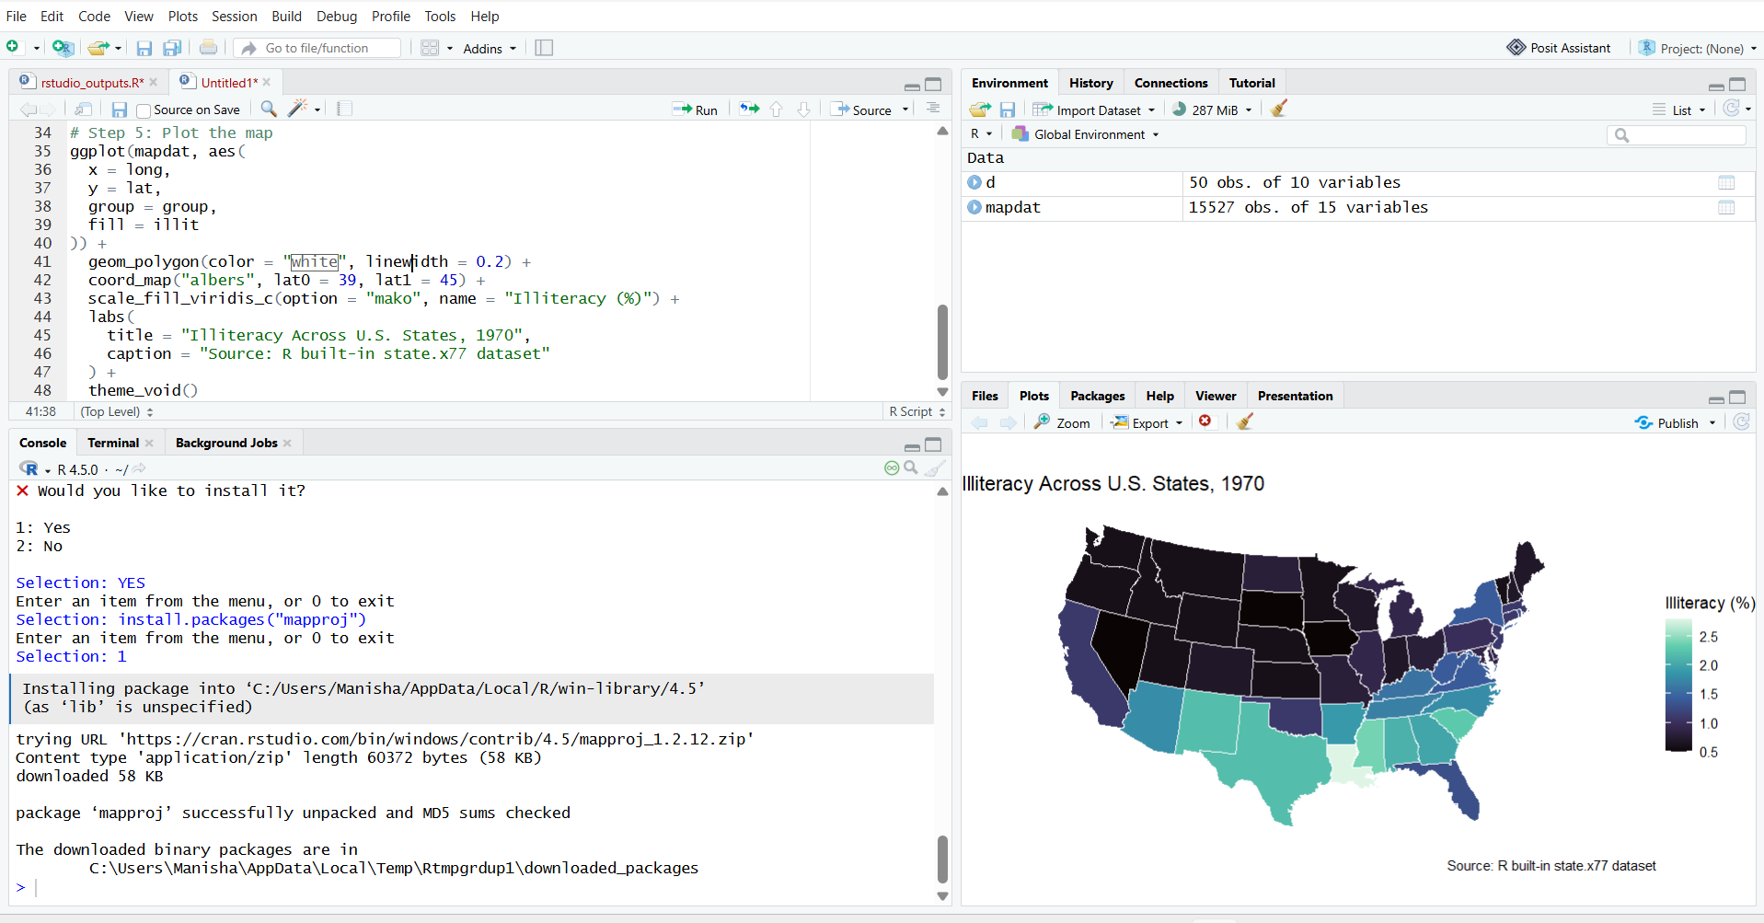

Question 2 — Regional means and correlation
# Mean illiteracy by region (all 50 states)
tapply(V, d$zone, mean)
# Pearson correlation between illiteracy and murder rate
cor(V, W)
cor.test(V, W)
Interpret the correlation using its sign and magnitude: |r| < 0.30 is weak, 0.30–0.70 is moderate, and |r| > 0.70 is strong. A positive r means states with higher illiteracy tend to have higher murder rates in this dataset; a negative r means the reverse. This is an association, not evidence that illiteracy causes murder.
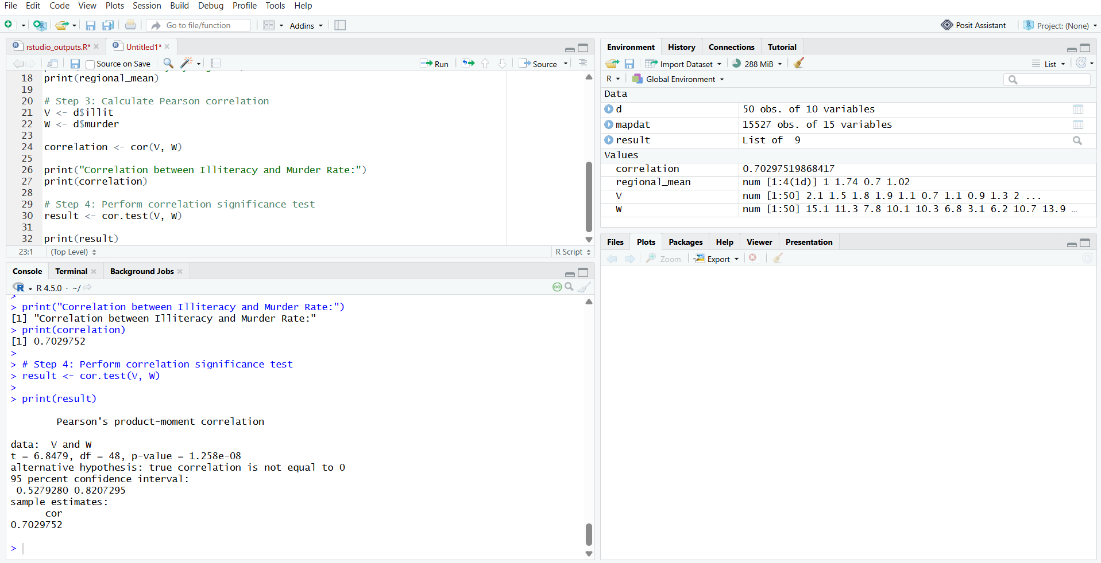

Question 3 — Equal-interval vs quantile classes
d$equal_class <- cut(V,
breaks=seq(min(V), max(V), length.out=6), include.lowest=TRUE)
d$quant_class <- cut(V,
breaks=quantile(V, probs=seq(0,1,length.out=6)),
include.lowest=TRUE)
mapdat <- merge(map_data("state"), d, by.x="region", by.y="state")
# Equal interval
ggplot(mapdat, aes(long, lat, group=group, fill=equal_class)) +
geom_polygon(colour="white", linewidth=0.25) +
coord_map("albers", lat0=29.5, lat1=45.5) +
scale_fill_viridis_d(option="mako", name="Illiteracy class") +
labs(title="Illiteracy: equal-interval classes") + theme_void()
# Quantiles
ggplot(mapdat, aes(long, lat, group=group, fill=quant_class)) +
geom_polygon(colour="white", linewidth=0.25) +
coord_map("albers", lat0=29.5, lat1=45.5) +
scale_fill_viridis_d(option="mako", name="Illiteracy class") +
labs(title="Illiteracy: quantile classes") + theme_void()
Equal-interval classes use equal numeric widths and can make high values look rare when most states cluster near the low end. Quantile classes aim to put similar numbers of states in each class, making ranks easier to compare, but may hide how large the numeric gaps are and can create narrow class intervals when values cluster.
Choice: use quantiles for an audience primarily comparing relative rank across states; use equal intervals when the actual size of the illiteracy-rate differences is the main message.
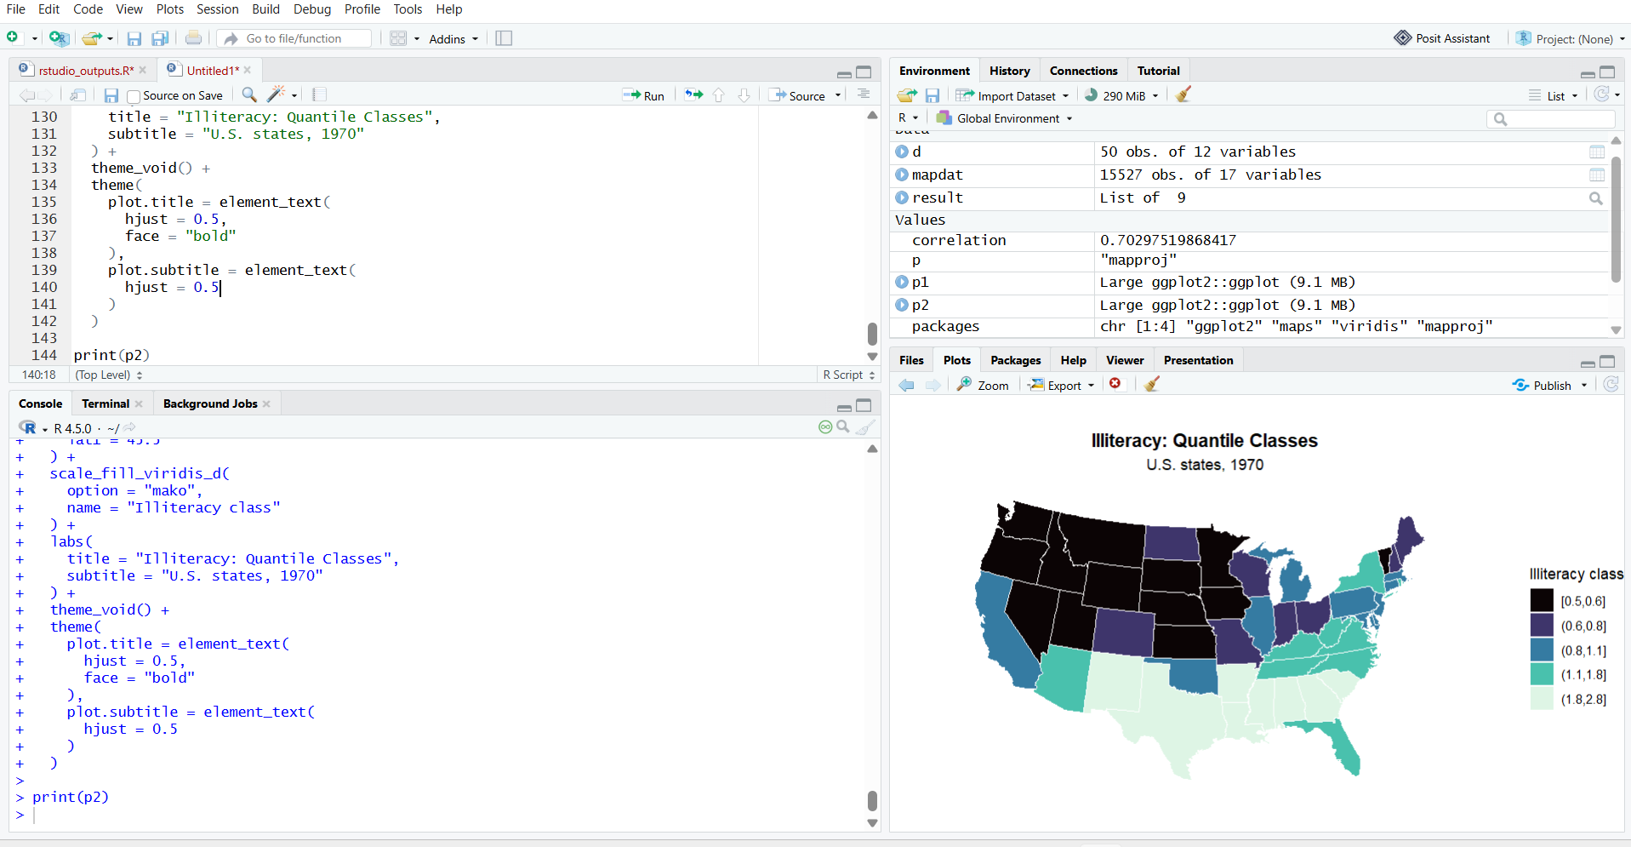

Question 4 — Counts versus rates
The task defines estimated illiterate people as population (in thousands) × 1,000 × illiteracy percentage / 100. The code below ranks states by that estimated count and separately by the illiteracy rate.
d$illiterate_people <- round(d$pop * 1000 * d$illit / 100)
top_counts <- head(d[order(-d$illiterate_people),
c("state","illiterate_people","illit")], 3)
top_rates <- head(d[order(-d$illit),
c("state","illit")], 3)
top_counts
top_rates
intersect(top_counts$state, top_rates$state)
The top-count list is influenced by both population size and illiteracy rate, whereas the top-rate list ranks the percentage only. The final intersect() command names any states appearing in both top-three lists. A count map would mostly highlight populous states, so map the illiteracy rate for a comparison of prevalence.
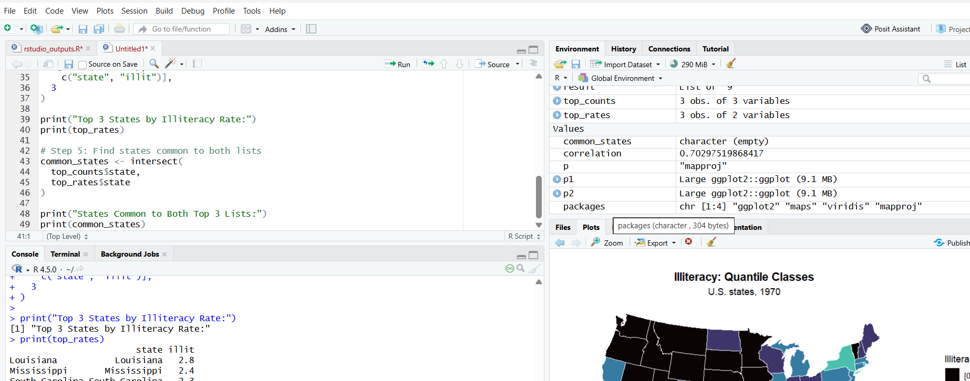

Question 5 — South-region story and headline
south <- subset(d, zone == "South")
national_median <- median(d$illit)
south_mean <- mean(south$illit)
south_ratio <- south_mean / mean(d$illit)
south[south$illit == max(south$illit), c("state","illit")]
sum(south$illit > national_median)
south_mean
south_ratio
national_median

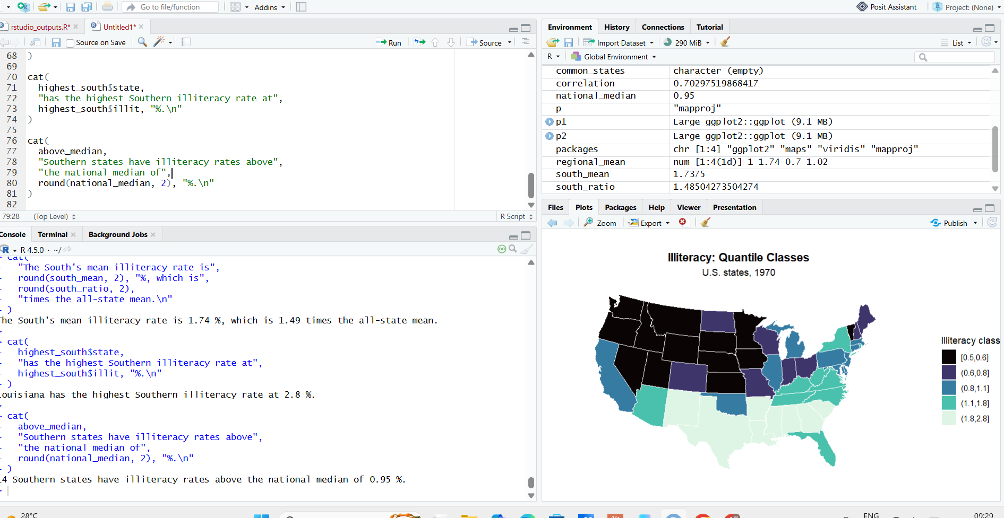

Suggested headline and evidence sentences
Headline template (fill the bracketed values using the R output): “Illiteracy gaps persist across the South”.
Evidence 1: “The South’s mean illiteracy rate is [south_mean]%—[south_ratio] times the all-state mean.”
Evidence 2: “[highest South state] has the highest South rate at [value]%, and [count] South states exceed the national median.”
Recommendation: use a rate-based map with a clear source note and follow up with targeted adult-literacy support in high-rate states; avoid treating state-level associations as proof about individuals.

